**NAME:** ABHAY RAHANGDALE DATE: 17-8-2023

**BRANCH: IOT 3RD YEAR SUBJECT CODE: IOT(2052)**

**SUBJECT: FOUNDATION OF DATA SCIENCE ENROLL NO.: 0108ME211003**

Q1. Write a Numpy program to get the Numpy version?

A1.

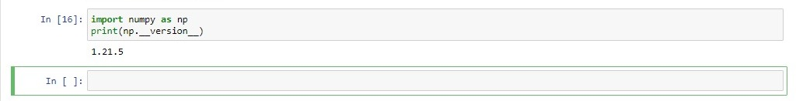

Q2. Write a NumPy program to test whether none of the elements of a given array are zero?

A2.

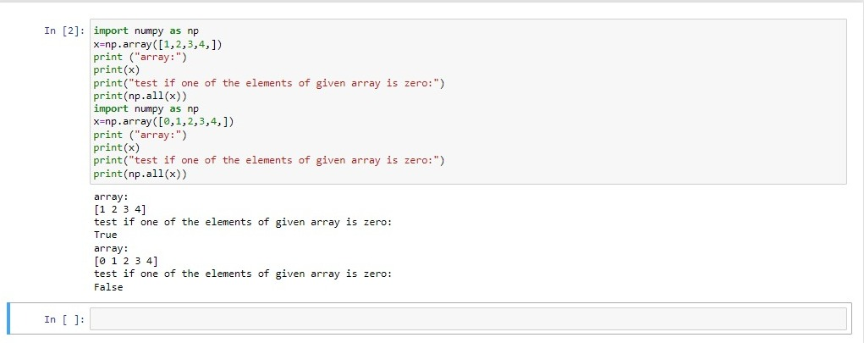

Q3. Write a NumPy program to create an element-wise comparison (greater, greater_equal, less and less_equal) of two given arrays?

A3. 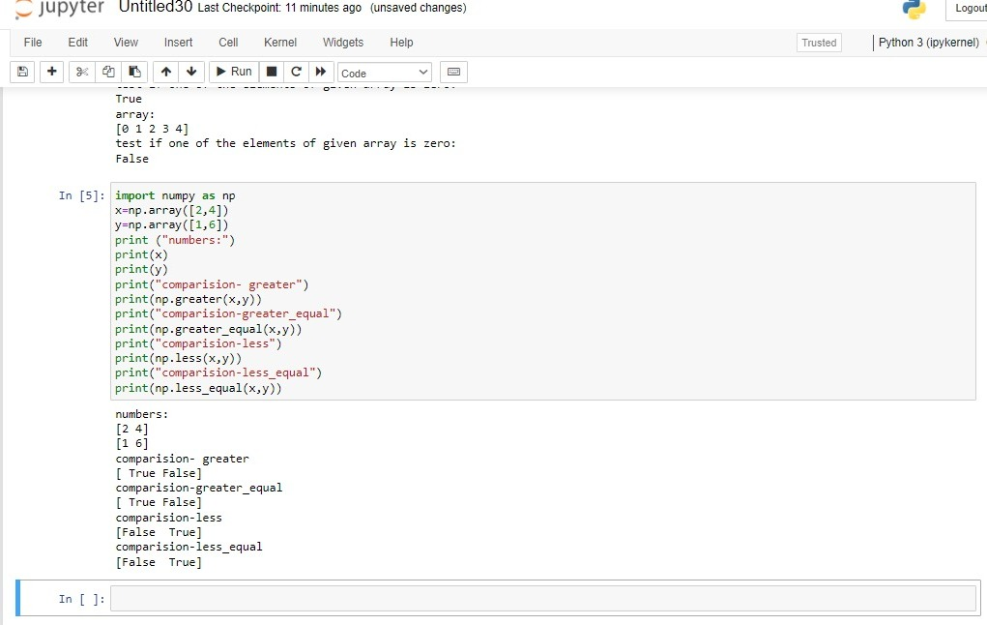

Q4. Write a NumPy program to create an array with the values 1, 7, 13, 105 and determine the size of the memory occupied by the array?

A4.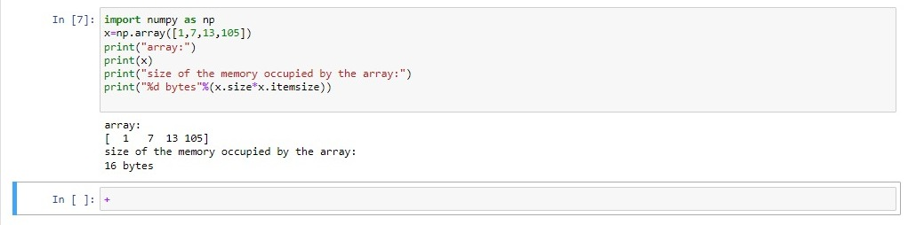

Q5. Write a NumPy program to create an array of integers from 30 to 70?

A5.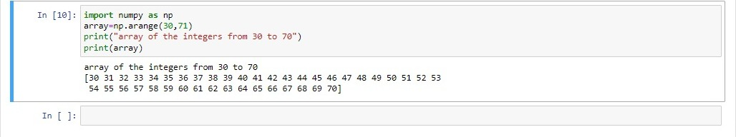

Q6. Write a NumPy program to create an array of all even integers from 30 to 70?

A6.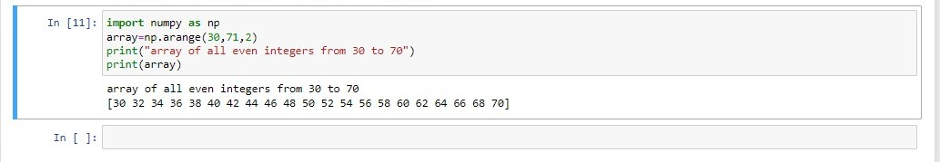

Q7. Write a NumPy program to create a 3x3 identity matrix?

A7.